Kill Switch Model

问与答

1. 怎么控制CI蛋白的量？

CI蛋白的量是可调控的，可以通过改变RBS强度改变mRNA翻译速率或者添加降解标签改变降解速率。

2．怎么解释自杀开关的有效性？

经改造的枯草芽孢杆菌在实验室培养阶段和在蚯蚓肠道中时都不自杀，是因为CI阻遏蛋白的作用，CI蛋白和DNA抑制位点结合阻止Toehold Switch的产生，自杀开关无法开启，此时的自杀开关是有效的。

3. 什么样的RBS和降解速率组合是最佳组合？

在蚯蚓肠道内，Toehold Switch的产生量是关键。由于有渗漏的可能性，Toehold Switch产生量不一定为0，我们需要模拟肠道环境下Toehold Switch的渗漏量，寻找生成最少Toehold Switch渗漏量的组合，若组合数不唯一，考虑到我们希望工程菌排出体外后自杀开关可以尽可能快的开启，降解速率较快的RBS和降解速率组合被认为是最佳组合。

Q&A

1. How can you control the amount of CI protein?

The amount of CI protein is controllable. We can change RBS strength to change mRNA translation rate or add degradation label to change the degradation rate.

1. How do you explain the effectiveness of the kill switch?

The modified *Bacillus subtilis* did not commit suicide in the laboratory and in the intestine of earthworms because the CI protein bound to the DNA inhibition site to prevent the Toehold Switch from being produced. The kill switch cannot be turned on.

1. Which is the best RBS and degradation rate combination?

In the intestine of earthworms, the production of Toehold Switch is the key. Due to the possibility of leakage, the production of Toehold Switch is not always set at 0. We simulated the leakage of Toehold Switch in the intestinal environment to find the combination that generated the least Toehold Switch leakage . If the combinations were not unique, considering that we hoped the kill switch could be turned on as soon as possible after the engineered bacteria were discharged out of the intestine, the RBS and a faster degradation rate combination was considered to be the best combination.

**1 摘要**

为了使枯草芽孢杆菌具有固铅能力，我们对枯草芽孢杆菌基因通路进行了改造，引入自杀开关，保证工程菌在蚯蚓肠道内不自杀，排出体外后立即开启自杀模式。为了验证自杀开关的有效性，我们建立了Kill Switch模型，模型将CI蛋白降解速率和不同的强度RBS进行组合，并定量模拟各种组合下自杀开关的效果，给出了最佳降解速率和RBS的组合。通过添加标签并选择RBS，CI蛋白的降解速率可达到，翻译速率可达到，自杀开关可以有效运行。

**1 ABSTRACT**

In order to make *Bacillus subtilis* capable of lead fixation, we modified the gene pathway of *Bacillus subtilis* by introducing a kill switch. The ensures that the engineered bacteria do not commit suicide in the intestine of the earthworm, but switch on the suicide mode after it is expelled out of the intestine. To verify the effectiveness of the kill switch, we built the Kill Switch model, which combines the degradation rate of CI protein with different strength RBS. After we quantitatively simulated the effect of the kill switch under various combinations, the best degradation rate and the combination of RBS are given. By adding the tag and selecting RBS, the degradation rate of the CI protein can be achieved, the translation rate can be achieved, and the kill switch can operate effectively.

**2 背景**

经改造的枯草芽孢杆菌会分泌CI阻遏蛋白，CI蛋白的含量直接决定Toehold Switch的量，而蚯蚓肠道内产生的Toehold Switch的量可以表征自杀开关开启的程度。CI蛋白的量受到RBS强度和降解速率的影响。我们关注三个阶段C1蛋白的量：

**实验室培养**

实验室添加IPTG诱导CI蛋白的产生。

**蚯蚓肠道内**

实验室诱导积累的CI蛋白降解，同时在无氧环境下，枯草芽孢杆菌表达CI蛋白和Trigger RNA。

**外界环境**

枯草芽孢杆菌随蚯蚓粪便排出体外后，CI蛋白和Trigger RNA不再产生，一直降解。随着CI浓度减少，游离的抑制位点增多，产生的Toehold Switch越来越多，并且可以和Trigger RNA结合开启自杀开关。

**2 BACKGROUND**

The modified *Bacillus subtilis* can secrete CI protein, the concentration of which directly determined the amount of Toehold Switch. We measured the Toehold Switch produced in the intestine of earthworms to represent whether the kill was turned on. The amount of CI protein was affected by RBS strength and degradation rate. We focused on the three stages:

**Laboratory culture phase**

The addition of IPTG in the lab induces the production of CI protein

**In the intestine of an earthworm**

 The accumulated CI protein induced in laboratory degrades , and in the absence of oxygen, *Bacillus subtilis* express CI protein and Trigger RNA.

**External Environment**

When *Bacillus subtilis* is excreted in earthworm feces, CI protein and Trigger RNA are no longer produced and are always degraded. As the concentration of CI decreases and the number of free inhibition sites increases, more and more Toehold Switches are produced, which can combine with Trigger RNA to turn on the kill switch.

**3 模型假设**

**3 MODEL HYPOTHESIS**

1. The degradation rate of mRNA is a constant.  
2. The mRNA is generated at a constant constitutive transcription rate.  
3. The copy number of plasmids is kept as a constant.  
4. Other species such as RNAP polymerases and ribosomes are kept constant as well.  
5. Reactions are at equilibrium, steady state, or quasi-steady state[[1]](https://2019.igem.org/Team:NAU-CHINA/PES_Model#i8).  
7. Each RBS part has a native strength irrespective of the promoter and protein-coding part it can be used with, and the translation rate with the same RBS has a linear relationship with the mRNA length[[1]](https://2019.igem.org/Team:NAU-CHINA/PES_Model#i8).

8. Toehold Switch will not be generated only when both inhibition sites are occupied.

9. Since the probability of gene mutation is very small, our model did not consider gene mutation.

**4 符号说明**

**4 SYMBOLIC DESCRIPTION**

|  |  |  |  |
| --- | --- | --- | --- |
| **Variables** | **Explanation** | **Value** | **Units** |
| K_{mRNA-CI} | The transcriptional rate of DNA_{CI} | **5** | min <sup> $-1$ </sup> |
| K<sub> mRNA-TS </sub> | The transcriptional rate of DNA<sub>TS </sub> |
| K<sub> CI-2 </sub> | The rate of translation of mRNA<sub> CI</sub> in the intestine of earthworms |  |
| d<sub> mRNA-TS </sub> | The degradation rate of mRNA <sub> TS </sub> | **0.3** |
| d<sub> mRNA- CI</sub> | The degradation rate of mRNA<sub> CI</sub> |
| d<sub>TS</sub> | The degradation rate of Toehold Switch |
| d<sub> CI-2 </sub> | The degradation rate of CI produced in earthworm intestine |  |  |
| d<sub> CI-1</sub> | The degradation rate of CIinduced in laboratory |  |  |
| [G<sub> CI</sub>] | CI encoding sequence concentration constant | 2.54\times10<sup>-9</sup> | **M** |
| [G<sub>TS</sub>] | Toehold Switch encoding sequence concentration constant |
| V<sub> mRNA-CI</sub> | The formation rate of mRNA <sub> CI</sub> |  |  |
| V<sub> CI</sub> | The formation rate of CI |  |  |
| V<sub>mRNA-TS</sub> | The formation rate of mRNA <sub> TS</sub> |  |  |
| V<sub>TS</sub> | The formation rate of Toehold Switch |  |  |
| $ε$ <sub>1</sub> | The coefficient of CI protein and inhibitory site binding |  |  |

**5 建构模型**

通过调控CI蛋白的量，可以控制自杀开关是否开启。实验室阶段我们选择能产生最多CI蛋白的IPTG的浓度进行诱导。进入肠道后利用模型同时调节RBS强度和CI蛋白降解速率，以达到在蚯蚓肠道内产生的Toehold Switch最少的效果。

**5.1 RBS和降解标签**

**RBS**

RBS序列又叫SD (Shine-Dalgarno) 序列，是控制翻译起始和蛋白质表达的关键区域，因此决定着翻译水平的高低，有研究表明运用合适的RBS可以增强相关蛋白质的表达，调控代谢流，提高目的产物的产量<sup>[3]/sup>。因此我们可以通过选取RBS强度改变CI蛋白的产生量。

为了选取较为合适的RBS，我们选取不同强度RBS进行了测试，如表5.1.1

表 5.1.1 四种RBS

|  |  |  |  |
| --- | --- | --- | --- |
| **RBS名称** | strength | translation rate(min-1) | sequence |
| B0034_CI_LVA | 36680.2 | 5.342068074 | TCTAGAGAAAGAGGAGAAATACTAGATG |
| B0064_CI_LVA | 22866.88 | 3.330309802 | TCTAGAGAAAGAGGGGAAATACTAGATG |
| B0029_CI_LVA | 3932.93 | 0.572788038 | TCTAGAGTTCACACAGGAAACCTACTAGATG |
| B0033_CI_LVA | 312.26 | 0.045477238 | TCTAGAGTCACACAGGACTACTAGATG |

**CI降解标签**

蛋白降解率取决于多种因素: ClpXP和ClpAP蛋白酶和SspB介质浓度；蛋白质的稳定性; 与蛋白酶结合的Km; 温度等等，但我们可以通过添加标签改变其降解速率，标签被ClpX解折叠酶识别，与ClpP蛋白酶形成复合物，标签的最后三个残基决定了与ClpX的相互作用强度，从而决定

了最终的蛋白质降解率。

我们选择LAA、LVA、AAV、ASV四个标签，在LAA和LVA的作用下CI降解速率可达到0.018 min <sup> $-1$ </sup> ,添加AAV和ASV标签后降解速率可分别达0.012 min <sup> $-1$ </sup>和0.0062min <sup> $-1$ </sup> <sup> $[4]$ </sup>。

由于CI蛋白的表达涉及实验室和蚯蚓肠道两个阶段，我们可以同时对两个阶段的降解速率进行调控，分别为两个阶段的CI蛋白选择两种的降解标签，根据四个标签产生三种不同的降解速率效果，目前有如表5.1.2中共9种组合方案供选择。

表5.1.2 不同降解速率C1蛋白组合

**CI-1**

|  |  |  |  |
| --- | --- | --- | --- |
| **CI-2** | LAA / LVA | AAV | ASV |
| LAA / LVA | 0.018 | 0.012 / 0.018 | 0.0062 /0.018 |
| AAV | 0.018 / 0.012 | 0.012 | 0.0062 / 0.012 |
| ASV | 0.018 / 0.0062 | 0.012 / 0.0062 | 0.0062 |

**5 MODEL**

By regulating the amount of CI protein, we can control the kill switch. In the laboratory stage, we selected the concentration of IPTG which could produce the most CI protein. After entering the intestinal tract, RBS strength and CI protein degradation rate were adjusted by using our model to achieve the minimum amount of Toehold Switch.

**5.1 RBS and Degradation tag**

**RBS Selection**

RBS sequence, also called SD (Shine-Dalgarno) sequence, is a key controlling the initiation of translation and the expression of proteins. Therefore, it determines the level of translation, increasing yield of target product<sup>[3]/sup>. We can change the production ofCIprotein by selecting suitable RBS strength.

To select a more suitable RBS, We selected RBS with different strengths for the test, as shown in Table 5.1.1

Table 5.1.1 Four types of RBS

|  |  |  |  |
| --- | --- | --- | --- |
| **Name of RBS** | **strength** | **translation rate (min <sup>-1</sup>)** | **sequence** |
| B0034_CI_LVA | 36680.2 | 5.342068074 | TCTAGAGAAAGAGGAGAAATACTAGATG |
| B0064_CI_LVA | 22866.88 | 3.330309802 | TCTAGAGAAAGAGGGGAAATACTAGATG |
| B0029_CI_LVA | 3932.93 | 0.572788038 | TCTAGAGTTCACACAGGAAACCTACTAGATG |
| B0033_CI_LVA | 312.26 | 0.045477238 | TCTAGAGTCACACAGGACTACTAGATG |

**C1 Degradation Tags**

The exact rate of protein degradation depends on a number of factors: the concentration of CLPXP and ClpAP protease and SspB medium; the stability of the protein; the km with the protease binds; the temperature, etc. But we can change the rate of degradation by adding tags. The tags can be recognized by the CLPX foldase and forms a complex with the ClpP protease. The last three residues of the tag determine the strength of the interaction with Clpx, thus determining the ultimate protein degradation rate.

We chose four tags: LAA, LVA, AAV and ASV. Under the LAA tag and LVA tag, the degradation rate of CI reached 0.018 min <sup>-1</sup> , and the degradation rate reached 0.012 min <sup>-1</sup>and 0.0062 min <sup> $-1$ </sup> due to AAV and ASV tag<sup>[4]/sup>..

*Bacillus subtilis* expresses CI protein both in the laboratory and in the intestine of earthworms. We can control the degradation rate of both stages at the same time, and choose two degradation tags for the two stages. Respectively, we got three different degradation rate effects, as shown in Table 5.1.2.

Table 5.1.2 C1 degradation rate combinations

**CI-1**

|  |  |  |  |
| --- | --- | --- | --- |
| **CI-2** | **LAA / LVA** | **AAV** | **ASV** |
| **LAA / LVA** | 0.018 | 0.012 / 0.018 | 0.0062 /0.018 |
| **AAV** | 0.018 / 0.012 | 0.012 | 0.0062 / 0.012 |
| **ASV** | 0.018 / 0.0062 | 0.012 / 0.0062 | 0.0062 |

**5.2 自杀开关**

组成型表达不受时期、部位、环境影响,没有时空特异性，编码蛋白质的基因不依赖于任何转录因子，因此它将连续转录信使RNA分子，然后蛋白质的翻译将不受控制[2]. 我们的枯草芽孢杆菌在蚯蚓肠道内表达CI蛋白的过程可以简单表示为图5.2.1.

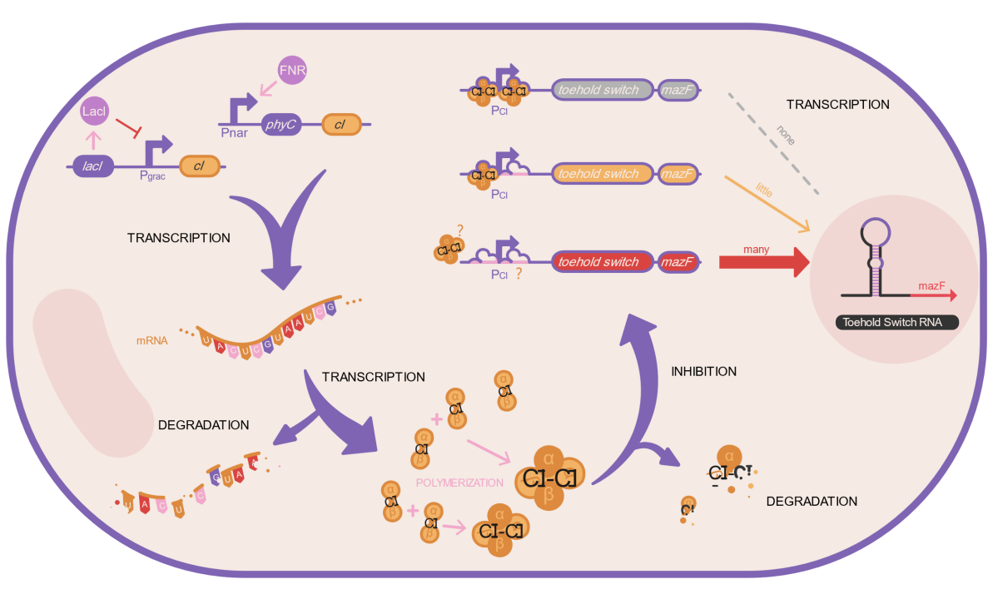

图5.2.1 C1蛋白的生成

关于CI蛋白的表达过程可以简单转化为以下化学反应，

$$DNA\backslash overset\{K_\{mRNA-CI\}\}\{\backslash rightarrow\}mRNA$$

$$mRNA\backslash overset\{K_\{CI\}\}\{\backslash rightarrow\}mRNA+CI \\ mRNA\backslash overset\{d_\{mRNA\}\}\{\backslash rightarrow\}\backslash phi$$

$$CI\backslash overset\{d_\{CI\}\}\{\backslash rightarrow\}\backslash phi$$

## 这里，我们应用微分方程表示各物质浓度，关于 ${mRNA}_{C1}$ 的浓度可以有如下表示：

$$\backslash frac\{\backslash mathrm\{d\}\backslash left[mRNA_\{CI\}\backslash right]\}\{\backslash mathrm\{d\}t\}=\{V_\{mRNA-CI\}\}-\backslash left [ mRNA_\{CI\}\backslash right ]d_\{mRNA-CI\}$$

其中， $d_{mRNA-C = 1 \backslash * ROMAN I}$ 是 ${mRNA}_{C = 1 \backslash * ROMAN I}$ 的降解速率， $V_{mRNA-C = 1 \backslash * ROMAN I}$ 是 ${mRNA}_{C = 1 \backslash * ROMAN I}$ 的生成速率，可以如下表示：

$$V_\{mRNA-CI\}= K_\{mRNA-CI\}\backslash left [ G_\{CI\}\backslash right ]$$

其中， $K_{mRNA-C1}$ 是转录速率，且 $K_{mRNA-C1}=5 \min^{-1}$， $[G_{C1}]$ 是 $C = 1 \backslash * ROMAN I$ 编码序列浓度常数。

接下来有：

$$\backslash frac\{\backslash mathrm\{d\}\backslash left [ CI\backslash right ]\}\{\backslash mathrm\{d\}t\}=V_\{CI\}-\backslash left [ CI-2\backslash right ]d_\{CI-2\}-\backslash left [ CI-1\backslash right ]d_\{CI-1\}$$

这里的 $d_{C1-1}$ 是实验室诱导产生的 $C = 1 \backslash * ROMAN I$ 蛋白降解速率， $d_{C1-2}$ 是蚯蚓肠道产生的CI蛋白的降解速率，二者都是可以调节的量， $V_{C = 1 \backslash * ROMAN I}$ 是生成速率：

$$V_\{CI\}=K_\{CI-2\}\backslash left [ mRNA_\{CI-2\}\backslash right ]$$

$K_{C1-2}$ 肠道内产生CI时的翻译速率，可以通过调整RBS强度改变。

为了解决Toehold Switch的浓度问题，我们同样假设：

$$\backslash frac\{\backslash mathrm\{d\}\backslash left[mRNA_\{TS\}\backslash right]\}\{\backslash mathrm\{d\}t\}=\{V_\{mRNA-TS\}\}-\backslash left [ mRNA_\{TS\}\backslash right ]d_\{mRNA-TS\}$$

其中 $d_{mRNA-TS}$ 是恒定的， $d_{mRNA-TS}=0.3\min^{-1}$**, $V_{mRNA-TS}$** 是 ${mRNA}_{TS}$ 生成速率，由下边的式子给出：

$$\{V_\{mRNA-TS\}\}=\{K_\{mRNA-TS\}\}\backslash omega_\{1\}\backslash left [ G_\{TS\}\backslash right ]$$

$K_{mRNA-TS}=5 \min^{-1}$**, $\left[G_{TS}\right]=2.54{x10}^{-9}$ M, $ε_{1}$** 是与 $C = 1 \backslash * ROMAN I$ 和抑制位点结合有关的百分比：

$$\backslash omega _\{1\}=\backslash left ( \backslash frac\{\backslash left [ O_\{CI-1f\}\backslash right ]\}\{\backslash left [ O_\{CI-1\}\backslash right ]\}\backslash right )\backslash left ( \backslash frac\{\backslash left [ O_\{CI-2f\}\backslash right ]\}\{\backslash left [ O_\{CI-2\}\backslash right ]\}\backslash right )$$

最后涉及Toehold Switch浓度，用下边的式子表示： $$\backslash frac\{\backslash mathrm\{d\}\backslash left [ TS\backslash right ]\}\{\backslash mathrm\{d\}t\}=V_\{TS\}-\backslash left [ TS\backslash right ]d_\{TS\}$$

其中， $d_{TS}=0.3\min^{-1}$**， $V_{TS}= K_{TS} [{mRNA}_{TS}]$.**

**5.2 Kill Switch**

Constitutive expression, not affected by time, place, or environment, has no spatiotemporal specificity. The gene that encodes the protein is not dependent on any transcription factor, so it will continuously transcribe mRNA molecules, and then the translation of the protein will be out of control<sub>[2] </sub>. Ourexpression of CIprotein in the intestine of earthworm can be easily illustrated in Figure 5.2.1.



Fig 5.2.1．Production of $C = 1 \backslash * ROMAN I$ protein

The CI protein expression can be simply translated into the following biochemical reactions,

$$DNA\backslash overset\{K_\{mRNA-CI\}\}\{\backslash rightarrow\}mRNA$$

$$mRNA\backslash overset\{K_\{CI\}\}\{\backslash rightarrow\}mRNA+CI$$

$$mRNA\backslash overset\{d_\{mRNA\}\}\{\backslash rightarrow\}\backslash phi$$

$$CI\backslash overset\{d_\{CI\}\}\{\backslash rightarrow\}\backslash phi$$

Here, we use a differential equation to represent the concentration of each substance. The concentration of mRNA<sub>CI</sub> can be expressed as follows:

$$\backslash frac\{\backslash mathrm\{d\}\backslash left[mRNA_\{CI\}\backslash right]\}\{\backslash mathrm\{d\}t\}=\{V_\{mRNA-CI\}\}-\backslash left [ mRNA_\{CI\}\backslash right ]d_\{mRNA-CI\}$$

Where, **d<sub> mRNA- CI </sub>(0.3min <sup> $-1$ </sup>)** is the degradation rate of **mRNA<sub>CI</sub>** and **V<sub>mRNA-CI</sub>** is the generation rate of **mRNA<sub>CI</sub>,** which can be expressed as follows:

$$V_\{mRNA-CI\}= K_\{mRNA-CI\}\backslash left [ G_\{CI\}\backslash right ]$$

Where,  **K<sub>mRNA-CI</sub>** is the transcription rate, and **K<sub>mRNA-CI</sub>=5 min <sup> $-1$ </sup>**. $\left[G<sub>C = 1 \backslash * ROMAN I</sub>\right]$ is the CI coding sequence concentration constant.

Here's what follows:

$$\backslash frac\{\backslash mathrm\{d\}\backslash left [ CI\backslash right ]\}\{\backslash mathrm\{d\}t\}=V_\{CI\}-\backslash left [ CI-2\backslash right ]d_\{CI-2\}-\backslash left [ CI-1\backslash right ]d_\{CI-1\}$$

Here, **D<sub>CI-1</sub>** is the laboratory-induced degradation rate of CI protein, **D<sub>CI-2</sub>** is the degradation rate of CI protein produced by earthworm intestines, both of which can be adjusted, and **V<sub>CI</sub>** is the production rate:

$$V_\{CI\}=K_\{CI-2\}\backslash left [ mRNA_\{CI-2\}\backslash right ]$$

**K<sub>CI-2</sub>** is the translation rate of CIgenerated in intestine, which could be changed by adjusting RBS intensity.

In order to solve the concentration problem of Toehold Switch, we also assumed:

$$\backslash frac\{\backslash mathrm\{d\}\backslash left[mRNA_\{TS\}\backslash right]\}\{\backslash mathrm\{d\}t\}=\{V_\{mRNA-TS\}\}-\backslash left [ mRNA_\{TS\}\backslash right ]d_\{mRNA-TS\}$$

Where **d<sub>mRNA-TS</sub>** is constant, **d<sub>mRNA-TS</sub> = 0.3 min <sup> $-1$ </sup>** and **V<sub>mRNA-TS</sub>** is generation rate of **mRNA <sub> TS</sub>,** given by the following formula:

$$\{V_\{mRNA-TS\}\}=\{K_\{mRNA-TS\}\}\backslash omega_\{1\}\backslash left [ G_\{TS\}\backslash right ]$$

**K<sub>mRNA-TS</sub>=5 min <sup> $-1$ </sup>** , **[G<sub>TS</sub>]= $ε_{1}$** indicates the binding of CI and inhibition sites：

$$\backslash omega _\{1\}=\backslash left ( \backslash frac\{\backslash left [ O_\{CI-1f\}\backslash right ]\}\{\backslash left [ O_\{CI-1\}\backslash right ]\}\backslash right )\backslash left ( \backslash frac\{\backslash left [ O_\{CI-2f\}\backslash right ]\}\{\backslash left [ O_\{CI-2\}\backslash right ]\}\backslash right )$$

Finally, Toehold Switch concentration is represented by the following formula:

$$\backslash frac\{\backslash mathrm\{d\}\backslash left [ TS\backslash right ]\}\{\backslash mathrm\{d\}t\}=V_\{TS\}-\backslash left [ TS\backslash right ]d_\{TS\}$$

Where, **d<sub>mRNA-TS</sub>=0.3 min <sup> $-1$ </sup>, V<sub>TS</sub>= K<sub> TS</sub>[ mRNA <sub> TS</sub>].**

**5.3 CI 规则**

由于产生CI蛋白会形成二聚体和抑制位点结合，在本节，我们为这种结合制定了规则，**CI2**代表二聚体 $C = 1 \backslash * ROMAN I$ 阻遏物， $O_{C1-1}$ 和 $O_{C1-2}$ 代表两个CI抑制位点。

**二聚体C1阻遏物**

$[{C12}_{f}]$ + $\left[O_{C1-1f}\right]⇌[C12:O_{C1-1}]$

$[{C12}_{f}]$ + $\left[O_{C1-2f}\right]⇌[C12:O_{C1-2}]$

$\left[C12:O_{C1-1}\right]+ \left[O_{C1-2f}\right]$ $⇌ \left[O_{C1-1}:C12:O_{C1-2}\right]⇌ \left[C12:O_{C1-2}\right]+\left[O_{C1-1f}\right]$

$[{C12}_{f}]$ + $\left[D\right]⇌[C12:D]$

**操作区域1**

$[{C12}_{f}]$ + $\left[O_{C1-1f}\right]⇌[C12:O_{C1-1}]$

$\left[C12:O_{C1-1}\right]+ \left[O_{C1-2f}\right]$ $⇌ \left[O_{C1-1}:C12:O_{C1-2}\right]⇌ \left[C12:O_{C1-2}\right]+\left[O_{C1-1f}\right]$

**操作区域2**

$[{C12}_{f}]$ + $\left[O_{C1-2f}\right]⇌[C12:O_{C1-2}]$

$\left[C12:O_{C1-1}\right]+ \left[O_{C1-2f}\right]$ $⇌ \left[O_{C1-1}:C12:O_{C1-2}\right]⇌ \left[C12:O_{C1-2}\right]+\left[O_{C1-1f}\right]$

**关系：**

$\left[C12\right]= \left[{C12}_{f}\right]+\left[C12:O_{C1-1}\right]+$ $\left[C12:O_{C1-2}\right]+\left[O_{C1-1}:C12:O_{C1-2}\right]$ + $[C12:D]$

$\left[O_{C1-1}\right]=\left[O_{C1-1f}\right]+ \left[C12:O_{C1-1}\right]+$ $\left[O_{C1-1}:C12:O_{C1-2}\right]$

$\left[O_{C1-2}\right]=\left[O_{C1-2f}\right]+ \left[C12:O_{C1-2}\right]+$ $\left[O_{C1-1}:C12:O_{C1-2}\right]$

**在这里:**

$$\left[C12:O_{C1-1}\right]=K_{C1o1·}\left[{C12}_{f}\right]. \left[O_{C1-1f}\right]$$

$$\left[C12:O_{C1-2}\right]=K_{C1o2·}\left[{C12}_{f}\right]. \left[O_{C1-2f}\right]$$

$\left[O_{C1-1}:C12:O_{C1-2}\right]$ = $K_{C1o2·}λ_{12}\left[C12:O_{C1-1}\right]. \left[O_{C1-2f}\right]= K_{C1o1·}\left[C12:O_{C1-2}\right]. \left[O_{C1-1f}\right]$

$$\left[C12:D\right]=K_{C1d·}\left[{C12}_{f}\right]. \left[D_{f}\right]$$

[D] $= \left[C12:D\right]+\left[D_{f}\right]$

**5.3 CI Rules**

Since CI proteins were produced to form dimer and inhibitory site binding, in this section we had formulated rules for such binding, with CI2 representing the dimer CI repressor and O<sup> CI-1 </sup>and O<sup> CI-2 </sup>representing the two CI suppressor sites<sup>[4] </sup>.

**Dimer C1 repressor**

$$\backslash left [ CI2_\{f\}\backslash right ]+\backslash left [ O_\{CI-1_\{f\}\}\backslash right ]\backslash rightleftharpoons \backslash left [ CI2:O_\{CI-1\}\backslash right ]$$

$$\backslash left [ CI2_\{f\}\backslash right ]+\backslash left [ O_\{CI-2_\{f\}\}\backslash right ]\backslash rightleftharpoons \backslash left [ CI2:O_\{CI-2\}\backslash right ]$$

$$\backslash left [ CI2:O_\{CI-1\}\backslash right ]+\backslash left [ O_\{CI-2_\{f\}\}\backslash right ]\backslash rightleftharpoons \backslash left [ O_\{CI-1\}:CI2:O_\{CI-2\}\backslash right ]\backslash rightleftharpoons \backslash left [ CI2:O_\{CI-2\}\backslash right ]+\backslash left [ O_\{CI-1_\{f\}\}\backslash right ]\backslash right ]$$

$$\backslash left [ CI2_\{f\}\backslash right ]+\backslash left [ D\backslash right ]\backslash rightleftharpoons \backslash left [ CI2:D\backslash right ]\backslash right ]$$

**Operating area 1**

$$\backslash left [ CI2_\{f\}\backslash right ]+\backslash left [ O_\{CI-1_\{f\}\}\backslash right ]\backslash rightleftharpoons \backslash left [ CI2:O_\{CI-1\}\backslash right ]$$

$$\backslash left [ CI2:O_\{CI-1\}\backslash right ]+\backslash left [ O_\{CI-2_\{f\}\}\backslash right ]\backslash rightleftharpoons \backslash left [ O_\{CI-1\}:CI2:O_\{CI-2\}\backslash right ]\backslash rightleftharpoons \backslash left [ CI2:O_\{CI-2\}\backslash right ]+\backslash left [ O_\{CI-1_\{f\}\}\backslash right ]\backslash right ]$$

**Operating area 2**

$$\backslash left [ CI2_\{f\}\backslash right ]+\backslash left [ O_\{CI-2_\{f\}\}\backslash right ]\backslash rightleftharpoons \backslash left [ CI2:O_\{CI-2\}\backslash right ]$$

$$\backslash left [ CI2:O_\{CI-1\}\backslash right ]+\backslash left [ O_\{CI-2_\{f\}\}\backslash right ]\backslash rightleftharpoons \backslash left [ O_\{CI-1\}:CI2:O_\{CI-2\}\backslash right ]\backslash rightleftharpoons \backslash left [ CI2:O_\{CI-2\}\backslash right ]+\backslash left [ O_\{CI-1_\{f\}\}\backslash right ]\backslash right ]$$

**Relationship:**

$$\backslash left [ CI2\backslash right ]=\backslash left [ CI2_\{f\}\backslash right ]+\backslash left [ CI2:O_\{CI-1\}\backslash right ]+\backslash left [ CI2:O_\{CI-2\}\backslash right ]+\backslash left [ O_\{CI-1\}:CI2:O_\{CI-2\}\backslash right ]+\backslash left [ CI2:D\backslash right ]\backslash right ]$$

$$\backslash left [ O_\{CI-1\}\backslash right ]=\backslash left [ O_\{CI-1_\{f\}\}\backslash right ]+\backslash left [ CI2:O_\{CI-1\}\backslash right ]+\backslash left [ O_\{CI-1\}:CI2:O_\{CI-2\}\backslash right ]\backslash right ]$$

$$\backslash left [ O_\{CI-2\}\backslash right ]=\backslash left [ O_\{CI-2_\{f\}\}\backslash right ]+\backslash left [ CI2:O_\{CI-2\}\backslash right ]+\backslash left [ O_\{CI-1\}:CI2:O_\{CI-2\}\backslash right ]\backslash right ]$$

**Where:**

$$\backslash left [ CI2:O_\{CI-1\}\backslash right ]=K_\{CIo1\}\backslash cdot \backslash left [ CI2_\{f\}\backslash right ]\backslash cdot \backslash left [ O_\{CI-1_\{f\}\}\backslash right ]$$

$$\backslash left [ CI2:O_\{CI-2\}\backslash right ]=K_\{CIo2\}\backslash cdot \backslash left [ CI2_\{f\}\backslash right ]\backslash cdot \backslash left [ O_\{CI-2_\{f\}\}\backslash right ]$$

$$\backslash left [ O_\{CI-1\}:CI2:O_\{CI-2\}\backslash right ]=K_\{CIo2\}\backslash cdot \backslash lambda _\{12\}\backslash left [ CI2:O_\{CI-1\}\backslash right ]\backslash cdot \backslash left [ O_\{CI-2_\{f\}\}\backslash right ]=K_\{CIo1\}\backslash cdot\backslash left [ CI2:O_\{CI-2\}\backslash right ]\backslash cdot \backslash left [ O_\{CI-1_\{f\}\}\backslash right ]$$

$$\backslash left [ CI2；D\backslash right ]=K_\{CId\}\backslash cdot \backslash left [ CI2_\{f\}\backslash right ]\backslash cdot \backslash left [ D_\{f\}\backslash right ]$$

$$\backslash left [ D\backslash right ]=\backslash left [ CI2:D\backslash right ]+\backslash left [ D_\{f\}\backslash right ]$$

**6 Results & Analysis**

根据RBS和降解速率的不同组合，共计36种方案可选择。

在模拟每一种组合后，可得到蚯蚓肠道内Toehold Switch的量，CI蛋白的量，结果展示如下：

According to different combinations of RBS and degradation rate, a total of 36 schemes were available.

After simulating each combination, the amount of Toehold Switch and the amount of CI protein in the earthworm intestinal tract could be obtained, and the results were shown as follows:

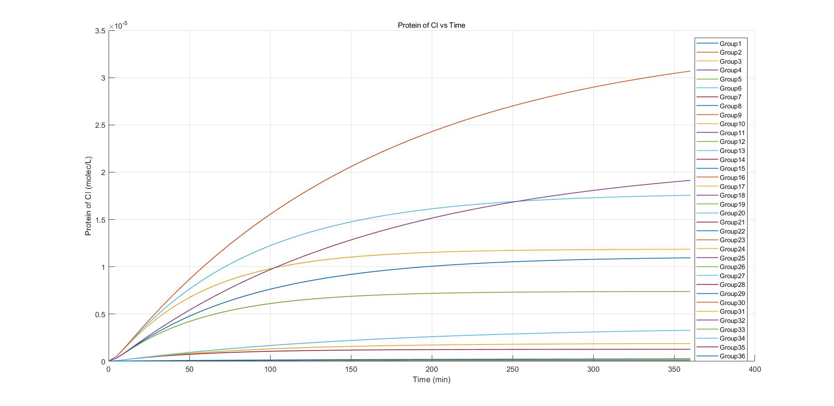

**7 参数敏感性分析**

实际上，启动子强度相关数据很难获得，启动子强度对CI 的产生的影响难以确定。为此，我们对启动子强度做敏感性分析，结果如图5.5.1

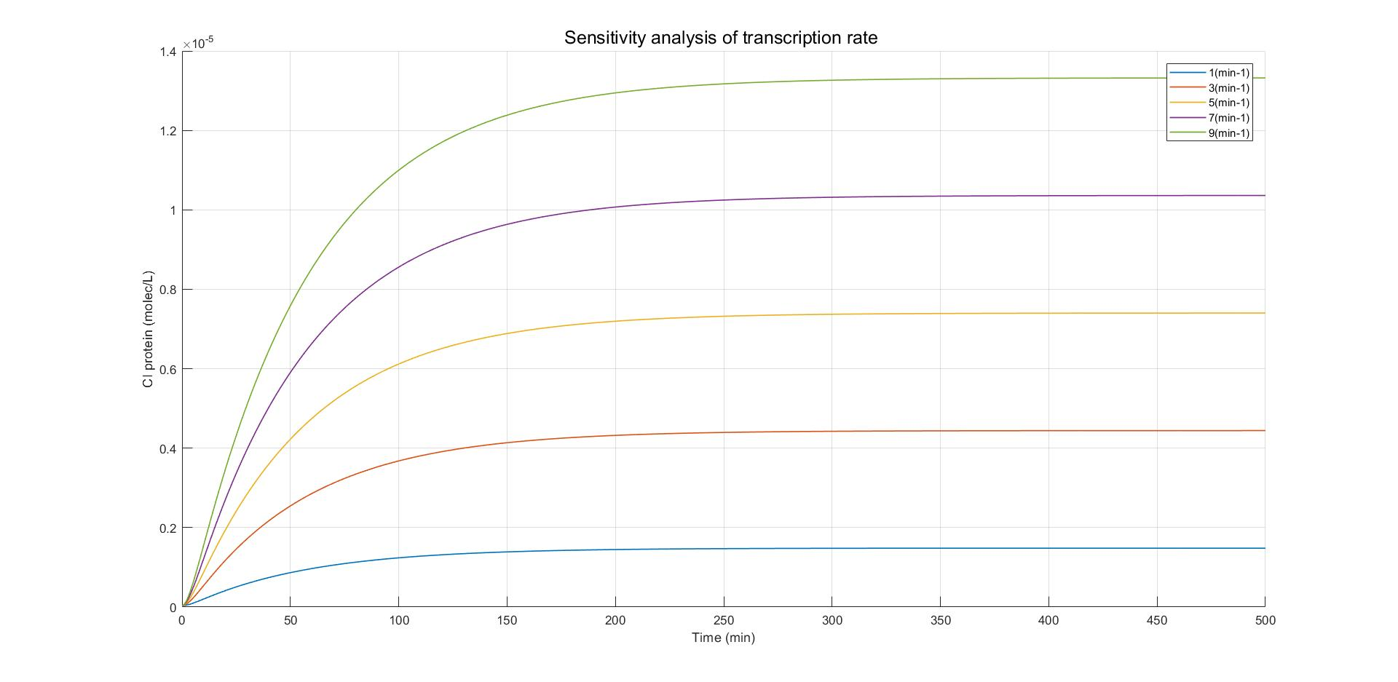

Fig 5.5.1

工程菌在实验室中经IPTG诱导产生部分CI蛋白，为了抑制Toehold Switch的产生，我们选择能产生最多CI蛋白的IPTG的浓度进行诱导。为探求CI-1的浓度对后续产生CI-2的浓度影响程度，我们对工程菌进入蚯蚓肠道时CI蛋白浓度进行敏感性分析。

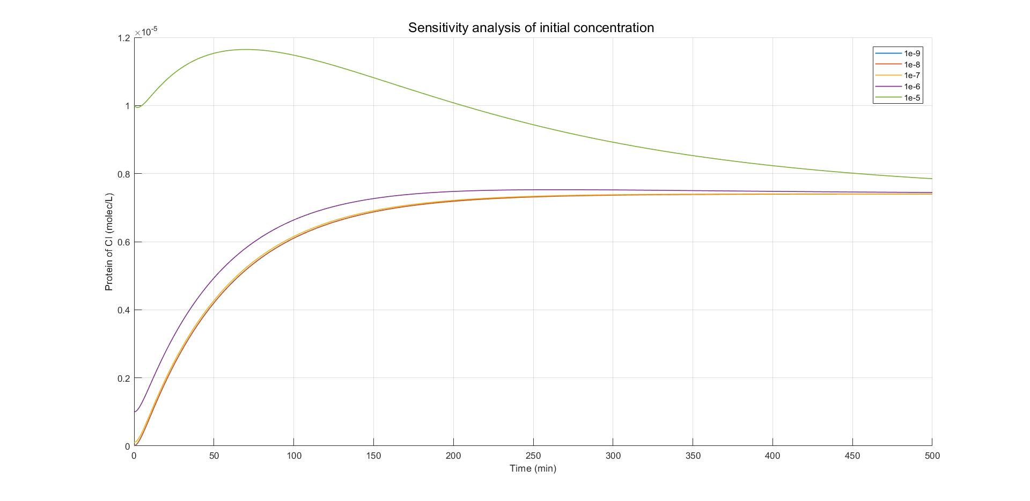

Fig 5.5.2

**7 Parameter Sensitivity Analysis**

In fact, data related to promoter strength is difficult to obtain, and the influence of promoter strength on CI is difficult to determine. Therefore, sensitivity analysis was performed on promoter strength, as shown in Figure 7.1



Fig 7.1

The engineered bacteria were induced to produce CI proteins by IPTG in the laboratory. we had selected the concentration of IPTG that could produce the most CI proteins to inhibit the production of Toehold Switch. And in order to explore the influence of CI-1 concentration on the subsequent generation of CI-2 concentration, we conducted a sensitivity analysis on the CI protein concentration of engineered bacteria when they entered the earthworm intestine, as shown in Figure 7.2.



Fig 7.2

**Reference**

[1] Zheng Y , Sriram G . Mathematical Modeling: Bridging the Gap between Concept and Realization in Synthetic Biology[J]. Journal of Biomedicine and Biotechnology, 2010, 2010(1110-7243):541609.

[2] Luan Ming Moon. Efficient expression of Glutamate decarboxylase by RBS sequence and promoter strategy. Kangnam University, 2018:3-5.

[3] Andersen JB, Sternberg C, Poulsen LK, Bjorn SP, Givskov M, Molin S. New unstable variants of green fluorescent protein for studies of

 transient gene expression in bacteria. Appl Environ Microbiol. 1998 Jun;64(6):2240-6. doi: 10.1128/AEM.64.6.2240-2246.1998. PMID: 9603842; PMCID: PMC106306.

[4] KIM, J. G.; TAKEDA, Y.; MATTHEWS, B. W.; ANDERSON, W. F. Kinetic studies on Cro repressor-operator DNA interaction. J Mol Biol, 196, n. 1, p. 149-158, Jul 1987

Download the source code (设置为链接)